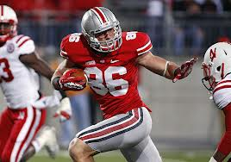
Jeff Heuerman
TE
Ohio State
6’5” 254 lbs.

Strengths | Weaknesses | Combine results
Team captain, unselfish | Foot injury | Bench- 26 reps (TP)
Hands; dangerous in the seam or on corner routes | Lower senior production than junior year | 40 yd dash- 4.80
Willing blocker | Needs to get stronger | Vertical jump- 34.5 inches
Improved blocker in 2014 | Gets redirected on routes | Broad jump- 120 inches
YAC ability | Out muscled when blocking
 | Lacked burst in 2014

Games watched: Clemson 2013, Purdue 2013, Cal 2014, Rutgers 2014
Summary: Jeff Heuerman is built in the mold of a prototypical TE in the NFL. However a foot injury and game planning derailed his production in his senior year. He was asked to be a blocker more than which proved to be the right decision with Ohio State winning the 2014 National Championship. While he did improve his blocking skills his senior year, to get a true glimpse at his ability look at his 2013 tape. He shows good hands and an ability to produce yards after the catch. His weaknesses lie in his functional strength; too many times he gets blown off the ball and re-routed off of his route. If he can bulk up and recover from his foot injury he will be a complete TE for an NFL team.
Scheme Fit: Balanced, West Coast
Comparison: John Carlson
Projected Round: 4th round
Best Fits: Atlanta Falcons, Pittsburgh Steelers, Oakland Raiders, NY Giants, San Diego Chargers

